Constructing Oval

Definition
# Source: AI Source: Provided by: [Data Path: Persons Table -> ID Column: 1, Name_En Column: Motasem Essam] -> From: [ChatGPT] on [7/25/2026]
Constructing an Oval is the process of creating a smooth, closed, rounded geometric shape using geometric construction methods.
The term oval is generally a descriptive geometric term, rather than the name of one uniquely defined mathematical curve. An oval may resemble an elongated circle and can be constructed using several methods depending on the required shape.
Important: An ellipse is a specific mathematical curve, while an oval is a broader descriptive term. Therefore, not every oval is necessarily an ellipse.

Fundamental Concept
# Source: AI Source: Provided by: [Data Path: Persons Table -> ID Column: 1, Name_En Column: Motasem Essam] -> From: [ChatGPT] on [7/25/2026]
An oval is generally characterized by:
- A closed boundary.
- A smooth or smoothly connected boundary.
- An elongated or rounded appearance.
- No sharp corners in the usual geometric meaning.
- A major direction and a minor direction.
- Symmetry in many standard constructions.
A common mathematical model for an oval is an ellipse:
$$\boxed{\frac{x^{2}}{a^{2}}+\frac{y^{2}}{b^{2}}=1}$$
where:
- $a$= semi-major axis
- $b$= semi-minor axis
- $a>b>0$
However, an oval can also be constructed from circular arcs or other smooth curves.

Main Construction Methods

1. Constructing an Oval From Two Axes
# Source: AI Source: Provided by: [Data Path: Persons Table -> ID Column: 1, Name_En Column: Motasem Essam] -> From: [ChatGPT] on [7/25/2026]
This method uses a major axis and a minor axis to create a smooth oval.
Steps
- Draw the major axis $\overset{‾}{AB}$.
- Find its midpoint $O$.
- Through $O$, construct a perpendicular line.
- Mark the required endpoints of the minor axis.
- Use the two axes to establish the overall dimensions of the oval.
- Construct intermediate points.
- Connect the points with a smooth curve.
The result is typically an ellipse-like oval.

2. Constructing an Oval Using Circular Arcs
# Source: AI Source: Provided by: [Data Path: Persons Table -> ID Column: 1, Name_En Column: Motasem Essam] -> From: [ChatGPT] on [7/25/2026]
An oval can be created by joining several circular arcs smoothly.
Steps
- Draw the major axis.
- Determine the desired width of the oval.
- Locate suitable arc centers along the major axis.
- Construct circular arcs with the required radii.
- Join the arcs so that they meet smoothly.
- Verify that the resulting boundary is closed.
This method is especially useful for technical drawing because circular arcs can be constructed accurately with a compass.

3. Constructing an Oval From a Rectangle
# Source: AI Source: Provided by: [Data Path: Persons Table -> ID Column: 1, Name_En Column: Motasem Essam] -> From: [ChatGPT] on [7/25/2026]
A rectangle can be used as a framework for constructing an elongated rounded shape.
Steps
- Construct the required rectangle.
- Identify its horizontal and vertical dimensions.
- Locate the centers required for the circular arcs.
- Construct arcs from the appropriate corners or auxiliary points.
- Join the arcs smoothly.
- Remove the construction lines if necessary.
This method is commonly useful for approximate or design-oriented oval shapes.

4. Constructing an Oval From an Ellipse
# Source: AI Source: Provided by: [Data Path: Persons Table -> ID Column: 1, Name_En Column: Motasem Essam] -> From: [ChatGPT] on [7/25/2026]
An ellipse can be used directly as a mathematically defined oval.
Given
- Semi-major axis $a$
- Semi-minor axis $b$
Construct:
$$\boxed{\frac{x^{2}}{a^{2}}+\frac{y^{2}}{b^{2}}=1}$$
The ellipse becomes more elongated as the difference between $a$and $b$increases.
If:
$$a=b$$
the ellipse becomes a circle.

5. Constructing an Oval Using the Foci-and-String Method
# Source: AI Source: Provided by: [Data Path: Persons Table -> ID Column: 1, Name_En Column: Motasem Essam] -> From: [ChatGPT] on [7/25/2026]
An ellipse-shaped oval can be constructed using two foci.
Steps
- Mark two points $F_{1}$and $F_{2}$.
- Place a loop or string around the two foci.
- Keep the string taut.
- Move a pencil around the foci while maintaining the string tension.
- The pencil traces the oval.
The defining property is:
$$\boxed{PF_{1}+PF_{2}=2a}$$
where $P$is any point on the ellipse.
This method constructs an ellipse, which is one mathematically precise type of oval.

Construction From a Given Major and Minor Axis
# Source: AI Source: Provided by: [Data Path: Persons Table -> ID Column: 1, Name_En Column: Motasem Essam] -> From: [ChatGPT] on [7/25/2026]
Suppose the major axis has length $2a$and the minor axis has length $2b$.
Construction
- Draw the major axis $\overset{‾}{AA^{'}}$.
- Find its midpoint $O$.
- Through $O$, construct a perpendicular line.
- Mark $B$and $B^{'}$so that:
$$OB=OB^{'}=b$$
- Thus:
$$OA=OA^{'}=a$$
- Construct additional points between the four vertices.
- Join the points with a smooth curve.
The four principal points are:
$$A, A^{'}, B, B^{'}$$
where:
- $A,A^{'}$are the major-axis vertices.
- $B,B^{'}$are the minor-axis vertices.

Mathematical Representation
# Source: AI Source: Provided by: [Data Path: Persons Table -> ID Column: 1, Name_En Column: Motasem Essam] -> From: [ChatGPT] on [7/25/2026]
For a horizontal oval modeled as an ellipse:
$$\boxed{\frac{x^{2}}{a^{2}}+\frac{y^{2}}{b^{2}}=1}$$
For an oval centered at $\left(h , k\right)$:
$$\boxed{\frac{{\left(x-h\right)}^{2}}{a^{2}}+\frac{{\left(y-k\right)}^{2}}{b^{2}}=1}$$
If the major axis is vertical:
$$\boxed{\frac{x^{2}}{b^{2}}+\frac{y^{2}}{a^{2}}=1}$$
with:
$$a>b>0$$

Important Elements
# Source: AI Source: Provided by: [Data Path: Persons Table -> ID Column: 1, Name_En Column: Motasem Essam] -> From: [ChatGPT] on [7/25/2026]
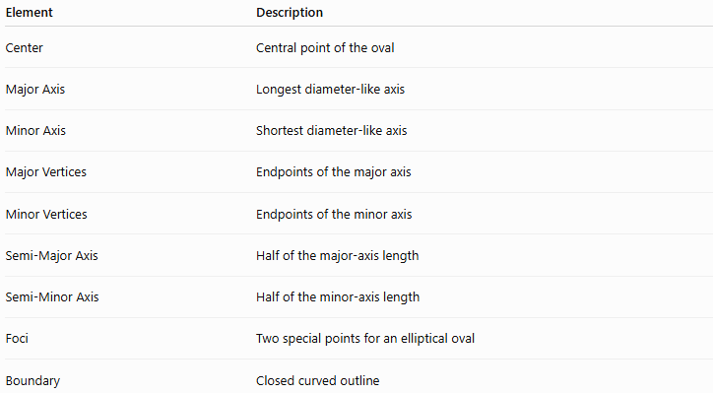
Element | Description
Center | Central point of the oval
Major Axis | Longest diameter-like axis
Minor Axis | Shortest diameter-like axis
Major Vertices | Endpoints of the major axis
Minor Vertices | Endpoints of the minor axis
Semi-Major Axis | Half of the major-axis length
Semi-Minor Axis | Half of the minor-axis length
Foci | Two special points for an elliptical oval
Boundary | Closed curved outline
For an ellipse:
$$\boxed{\text{Major Axis}=2a} \\ \boxed{\text{Minor Axis}=2b}$$

Properties of an Elliptical Oval
# Source: AI Source: Provided by: [Data Path: Persons Table -> ID Column: 1, Name_En Column: Motasem Essam] -> From: [ChatGPT] on [7/25/2026]
When the oval is an ellipse:
Symmetry
It has:
- One horizontal line of symmetry.
- One vertical line of symmetry.
- 180° rotational symmetry.
Focal Relationship
$$\boxed{c^{2}=a^{2}-b^{2}}$$
where $c$is the distance from the center to each focus.
Eccentricity
$$\boxed{e=\frac{c}{a}}$$
For an ellipse:
$$0≤e<1$$
Area
$$\boxed{A=πab}$$
Perimeter
Unlike a circle, an ellipse does not have a simple elementary exact perimeter formula. A commonly used approximation is:
$$P≈π\left[3\left(a+b\right)-\sqrt{\left(3a+b\right)\left(a+3b\right)}\right]$$

Types of Oval Construction
# Source: AI Source: Provided by: [Data Path: Persons Table -> ID Column: 1, Name_En Column: Motasem Essam] -> From: [ChatGPT] on [7/25/2026]
The following are construction methods/situations, rather than universally standardized mathematical types of ovals.
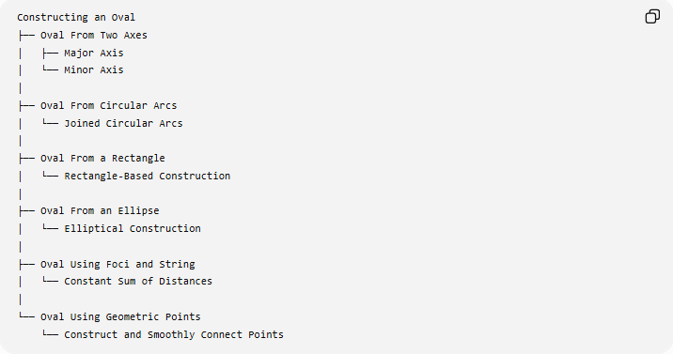
Constructing an Oval
├── Oval From Two Axes
│ ├── Major Axis
│ └── Minor Axis
│
├── Oval From Circular Arcs
│ └── Joined Circular Arcs
│
├── Oval From a Rectangle
│ └── Rectangle-Based Construction
│
├── Oval From an Ellipse
│ └── Elliptical Construction
│
├── Oval Using Foci and String
│ └── Constant Sum of Distances
│
└── Oval Using Geometric Points
└── Construct and Smoothly Connect Points

Basic Constructions Used
# Source: AI Source: Provided by: [Data Path: Persons Table -> ID Column: 1, Name_En Column: Motasem Essam] -> From: [ChatGPT] on [7/25/2026]
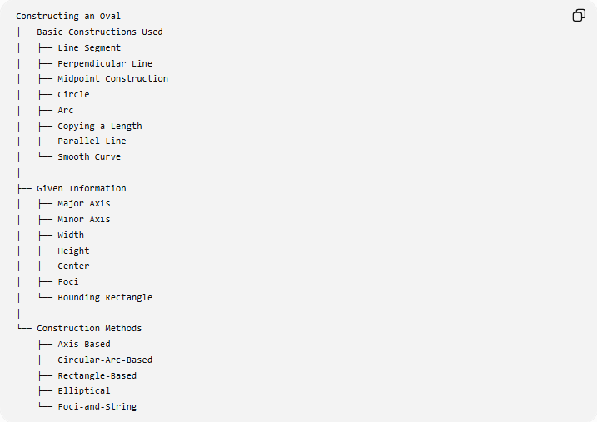
Constructing an Oval
├── Basic Constructions Used
│ ├── Line Segment
│ ├── Perpendicular Line
│ ├── Midpoint Construction
│ ├── Circle
│ ├── Arc
│ ├── Copying a Length
│ ├── Parallel Line
│ └── Smooth Curve
│
├── Given Information
│ ├── Major Axis
│ ├── Minor Axis
│ ├── Width
│ ├── Height
│ ├── Center
│ ├── Foci
│ └── Bounding Rectangle
│
└── Construction Methods
├── Axis-Based
├── Circular-Arc-Based
├── Rectangle-Based
├── Elliptical
└── Foci-and-String

Oval vs Ellipse vs Circle
# Source: AI Source: Provided by: [Data Path: Persons Table -> ID Column: 1, Name_En Column: Motasem Essam] -> From: [ChatGPT] on [7/25/2026]
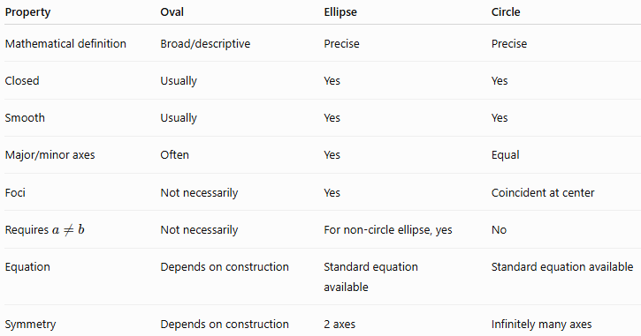
Property | Oval | Ellipse | Circle
Mathematical definition | Broad/descriptive | Precise | Precise
Closed | Usually | Yes | Yes
Smooth | Usually | Yes | Yes
Major/minor axes | Often | Yes | Equal
Foci | Not necessarily | Yes | Coincident at center
Requires $a≠b$ | Not necessarily | For non-circle ellipse, yes | No
Equation | Depends on construction | Standard equation available | Standard equation available
Symmetry | Depends on construction | 2 axes | Infinitely many axes
An important relationship is:
$$\boxed{\text{Circle is a special case of an ellipse}}$$
when:
$$a=b$$
An ellipse can therefore be used as a mathematically precise model of an oval.

Oval vs Circular-Arc Construction
# Source: AI Source: Provided by: [Data Path: Persons Table -> ID Column: 1, Name_En Column: Motasem Essam] -> From: [ChatGPT] on [7/25/2026]
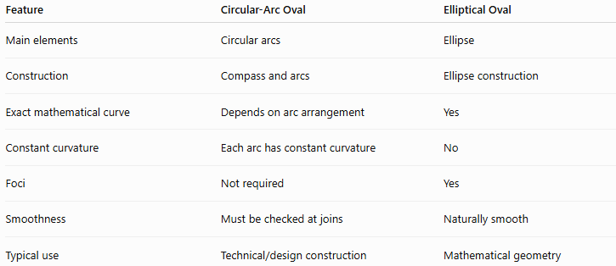
Feature | Circular-Arc Oval | Elliptical Oval
Main elements | Circular arcs | Ellipse
Construction | Compass and arcs | Ellipse construction
Exact mathematical curve | Depends on arc arrangement | Yes
Constant curvature | Each arc has constant curvature | No
Foci | Not required | Yes
Smoothness | Must be checked at joins | Naturally smooth
Typical use | Technical/design construction | Mathematical geometry

Example
# Source: AI Source: Provided by: [Data Path: Persons Table -> ID Column: 1, Name_En Column: Motasem Essam] -> From: [ChatGPT] on [7/25/2026]
Suppose an elliptical oval has:
$$a=6\text{ cm}$$
and:
$$b=4\text{ cm}$$
Then:
Major Axis
$$2a=12\text{ cm}$$
Minor Axis
$$2b=8\text{ cm}$$
Focal Distance
$$c=\sqrt{a^{2}-b^{2}} \\ c=\sqrt{36-16} \\ \boxed{c=2\sqrt{5}\text{ cm}}$$
Area
$$A=πab \\ A=π\left(6\right)\left(4\right) \\ \boxed{A=24π{\text{ cm}}^{2}}$$

Important Distinction
# Source: AI Source: Provided by: [Data Path: Persons Table -> ID Column: 1, Name_En Column: Motasem Essam] -> From: [ChatGPT] on [7/25/2026]
The word oval should not automatically be treated as a synonym for ellipse.
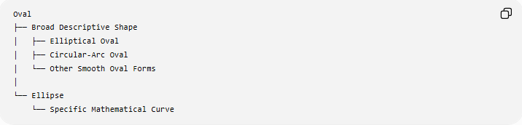
Oval
├── Broad Descriptive Shape
│ ├── Elliptical Oval
│ ├── Circular-Arc Oval
│ └── Other Smooth Oval Forms
│
└── Ellipse
└── Specific Mathematical Curve
Therefore:
$$\boxed{\text{Every ellipse may be described as an oval, but not every oval is necessarily an ellipse.}}$$

Classification Within Geometric Construction
# Source: AI Source: Provided by: [Data Path: Persons Table -> ID Column: 1, Name_En Column: Motasem Essam] -> From: [ChatGPT] on [7/25/2026]
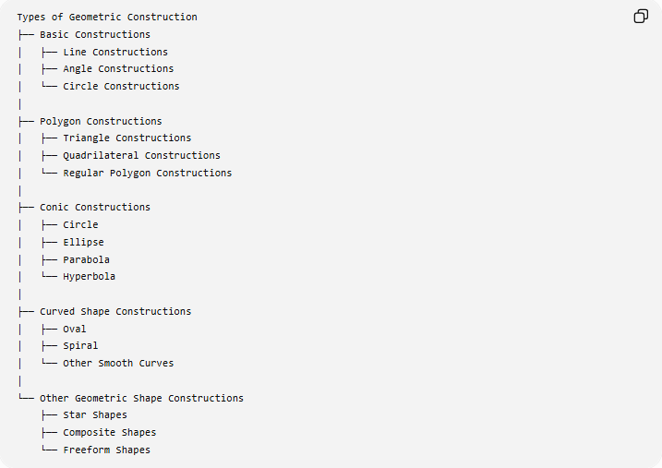
Types of Geometric Construction
├── Basic Constructions
│ ├── Line Constructions
│ ├── Angle Constructions
│ └── Circle Constructions
│
├── Polygon Constructions
│ ├── Triangle Constructions
│ ├── Quadrilateral Constructions
│ └── Regular Polygon Constructions
│
├── Conic Constructions
│ ├── Circle
│ ├── Ellipse
│ ├── Parabola
│ └── Hyperbola
│
├── Curved Shape Constructions
│ ├── Oval
│ ├── Spiral
│ └── Other Smooth Curves
│
└── Other Geometric Shape Constructions
├── Star Shapes
├── Composite Shapes
└── Freeform Shapes
Classification note: Oval is best treated here as a descriptive curved-shape category, not as a fundamental conic category. An ellipse, by contrast, is a mathematically defined conic.

Key Points
# Source: AI Source: Provided by: [Data Path: Persons Table -> ID Column: 1, Name_En Column: Motasem Essam] -> From: [ChatGPT] on [7/25/2026]
- An oval is a smooth, closed, rounded shape with an elongated appearance.
- Oval is generally a descriptive term rather than one uniquely defined mathematical curve.
- An ellipse is a specific mathematical curve and is a common precise model of an oval.
- An oval can be constructed using:
  - two axes,
  - circular arcs,
  - a rectangle framework,
  - an ellipse,
  - or the foci-and-string method.
- For an ellipse:
$$\boxed{\frac{x^{2}}{a^{2}}+\frac{y^{2}}{b^{2}}=1}$$
- Its major and minor axes are:
$$\boxed{2a, 2b}$$
- Its foci satisfy:
$$\boxed{c^{2}=a^{2}-b^{2}}$$
- Its area is:
$$\boxed{A=πab}$$
- A circle is a special ellipse when:
$$\boxed{a=b}$$
- Not every oval is necessarily an ellipse.

Conclusion
# Source: AI Source: Provided by: [Data Path: Persons Table -> ID Column: 1, Name_En Column: Motasem Essam] -> From: [ChatGPT] on [7/25/2026]
Constructing an Oval involves creating a smooth, closed, rounded shape using geometric elements such as axes, circles, arcs, points, or an ellipse. Because oval is a broad descriptive term, several construction methods are possible. For mathematically precise construction, the ellipse provides the most important model, while circular-arc and rectangle-based methods are useful for technical and design-oriented shapes.

